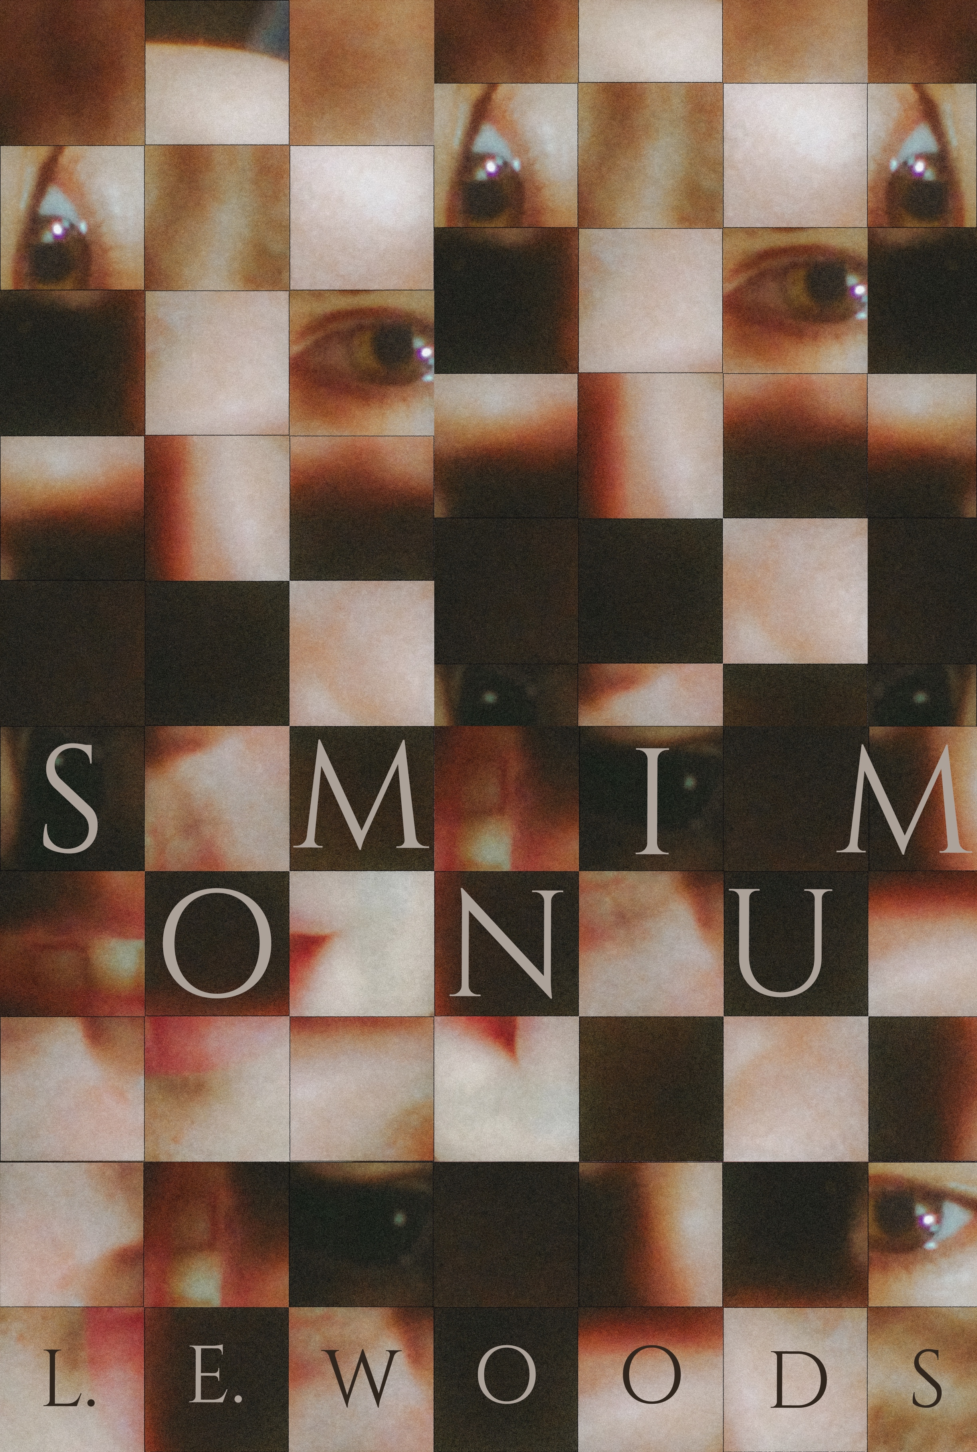
September 29, 2022

MOVIE: SOMNIUM

STARRING: MITCHELL PETERS, ANTHONY SOTO

DIRECTED BY: LEWIS E. WOODS

RATING: 3 ½ STARS (OUT OF 4)

Somnium is a short film from director Lewis E. Woods who co-wrote the script with Mitchell Peters. It’s a mysterious tale that begins with a boy waking up from a dream with a dark creature lurking in his bedroom shadows. Jumping ahead to present time the now adult boy, Elliot, played by Peters, is still plagued by the recurring nightmare. These opening scenes set up a foreboding atmosphere that seems to be reflecting challenging inner struggles.

Elliot and his boyfriend Jeremy have just arrived at a large mansion filled with beautiful paintings and English-style architecture. The plan is to stay there before an auction sells it all off. Both characters seem to be struggling a bit though. Jeremy, the more grounded of the two, expresses frustration at their sexual issues. Elliot is in greater turmoil and clearly haunted by his inner demons. There’s a quote at the beginning of the film by psychologist Carl Jung: “Man is whole only when he takes into account his shadow.” This becomes a clue for what Elliot and Jeremy seem to be experiencing. They both need to get in touch with their shadows to make themselves and their relationship whole.

Soon enough they do. Jeremy imagines a sexual encounter with a classical muscular Roman statue while Elliot senses the dark creature in their midst. There are plenty of doors creeking and wall shadows which suggest something is off in this castle-like setting. While it sounds a bit like a contemporary thriller, this one doesn’t create horror for horror film sake. Rather, Somnium is actually about the inner mind of the characters and their need to pull themselves together with their own darker drives.

One of the great motifs in the film is hands. Hands provide the pill that allows the men to “transcend” their consciousness. They also provide the necessary physical connection between them, their inner demons, and fantasies. The production design really stands out here too. In addition to the setting, the men wear complementary and symbolic colors: Jeremy in red is the more sexually charged. Elliot in blue is more sensitive and quiet. Even more significant are the costumes and makeup featured on the creatures that are depicted. Interestingly, Jeremy’s Roman statue is in white while Elliot’s dark creature is in black. Jeremy is also dark-haired while Elliot is blonde. So, in a sense they both represent opposite sides of the good/evil or yin/yang coin. Both are stellar visual images that represent extremes in their own right. Ultimately though it is through the touching of hands that bring these sides together so that both characters can become whole again, both individually and as a couple.

Somnium stands apart from similar genre films for it delves deeply into the psyche of the main characters while still remaining mysterious and intriguing throughout its 14-minute run.

Somnium plays Friday, September 30th as part of the Tales from the Queerside series of short films at Reeling: Chicago’s LGBTQ+ Film Festival at Chicago Filmmakers. It will also be available to be screened virtually the same day through October 6th.

For more reviews by Dan Pal go to AMovieGuy.com: Dan Pal Reviews

